CS 2341 – Fall 2020
Homework Assignment 4

Due: Nov 11, 2020 @ 11pm
Uploaded to Canvas

Submission Directions:
- Put your name inside the document in the header of the Word doc (or some equally
conspicuous place)
- Complete the questions below. Point values are indicated in square brackets.
- For questions that require diagrams, create the diagrams on your computer (no hand-
drawn/scanned diagrams). You can do this with PowerPoint, Google Draw, LibreOffice Draw, etc. Then copy-and-paste the diagrams into the correct place in the document you submit.
- For any code or pseudocode, please use a fixed-point mono font (courier for example) and consider appropriate spacing and indentation.
- Please submit a PDF file of your solutions.

1. For the tree that follows, provide a:
a) preorder traversal.
b) inorder traversal.
c) postorder traversal.
(5 points each)

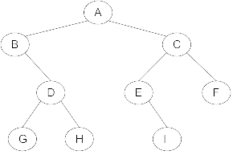

2. Use the characters from the string SMUMUSTANGCODERS to construct a binary search tree. Insert each letter from the string into a binary search tree starting with the first S and proceeding character-by-character from left to right. You only need to show the final tree. (10 points)

3. Assume a Binary Search Tree Class has the following structure:
class BSTree {
private:
struct BSTreeNode {
int x;
BSTreeNode* left, * right;
}
BSTreeNode* root;
//.. The rest of the class here…
};
Add a recursive countNodes member function and its public counterpart that will return an integer representing the total number of nodes in the Binary Search Tree. (10 points)

4. For a binary tree with x levels (empty tree has 0 levels; tree with 1 node has 1 level), what is the maximal number of nodes that can be stored in that tree? (5 points)

5. Use the characters from the string SMUMUSTANGCODERS to construct an AVL Tree. Insert each letter from the string into an AVL tree starting with the first S and proceeding character-by-character from left to right. Redraw the tree after each case of imbalance is corrected by a single or double rotation. (20 points)

